ARTI 502
Deep Learning: 2st Assignment
Training-Testing CNN with CIFAR Dataset using Pytorch
Year 2026 Term 1

Group # Group Members:
# | Member Name | Member Academic ID
1 | Ahmad Muhanna | 2230006180
2 | Hashim Aljarrash | 2230000215
3 | Mohammed Alammari | 2230003182
4 | Ali Alshehri | 2230002515
5 | Osama Al Haddaf | 2230001201

Overview
In this assignment, we will have you train some convolutional neural networks and will use a small dataset (CIFAR).

Objective
To implement two core building blocks to deep learning:
- Convolution layers
- Maxpooling layers.

Tasks (with PyTorch)

Task 1: Getting the CIFAR Dataset

Instructions:
- Download the dataset first. Since PyTorch hosts the CIFAR dataset, you can load it using their helper function later.
- You need to change DATA_PATH to an empty directory to download the dataset to.

Deliverable:
Screenshot showing the dataset loaded successfully.
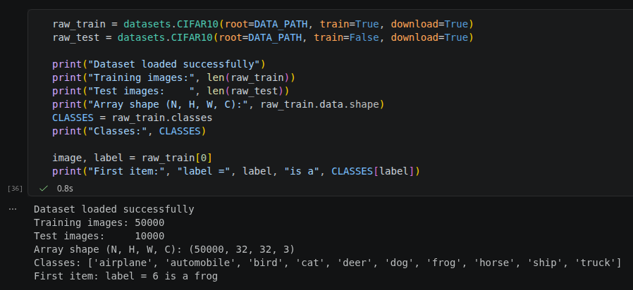

Task 2: Defining the Network

Instructions:
- Just like with MNIST in the first assignment you need to define your network architecture. This time you will be using convolutional layers and maxpooling to extract features from our images before you feed those features into your final classifier.
- Check out the documentation for nn.Conv2d

- So the first parameter is the number of channels in the input. Second is the number of filters we'll use (AKA number of channels in the output). Third is kernel size. Next is stride and padding which are optional and have default values.
- Create your training and test functions

Deliverable:
- Provide screenshots of your code to define your network
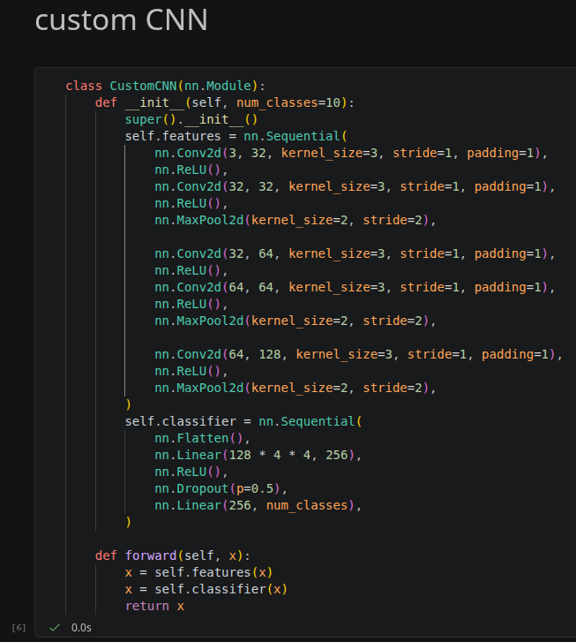
- Show screenshoots of your training and test functions.

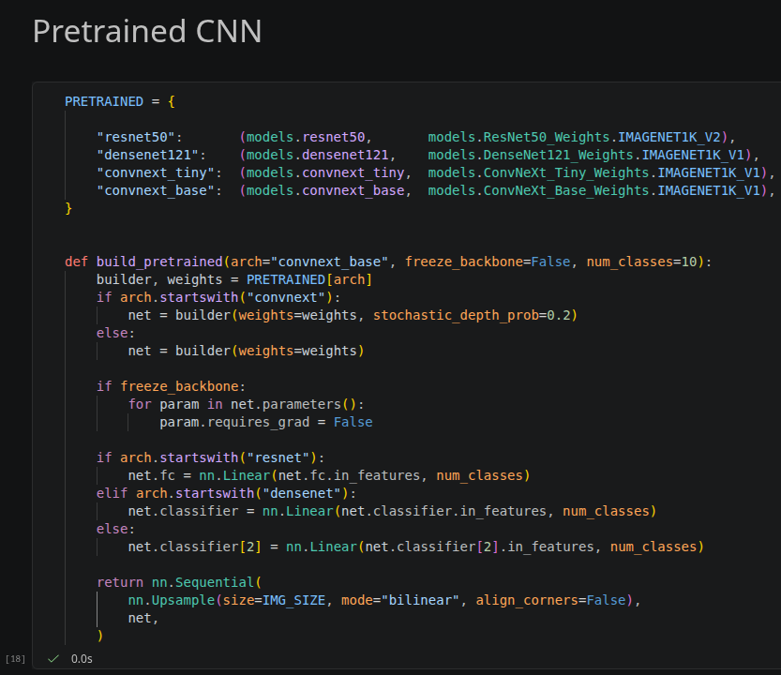
Here, our transfer learning networks. PRETRAINED is a dictionary that has the models we chose and their respective weights, which are then used in build_pretrained, the function takes the architecture and builds a network with those weights then replaces the last fully connected layer or classifier by (input_features, 10) 10 are the classes for CIFAR10, the original models are trained from imagenet which had much more classes (1000) so we reduced them into 10 to fit our dataset. The if-statements are used because different transfer models have different naming for their layers.

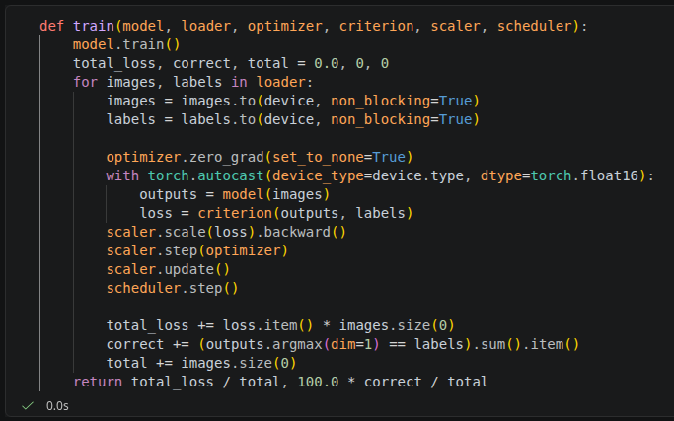
We used mixed-precision to make the computations faster in our machine, which required the autocast dtype float16, and a scaler.
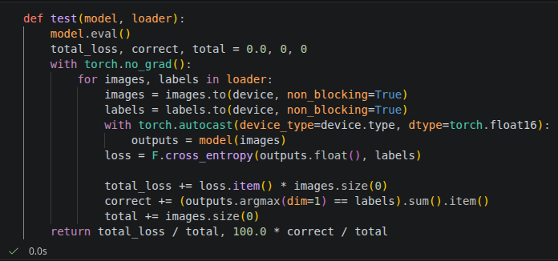

Task 3: Loading Data

Instructions:
- It's worthwhile to check out how the dataloader loads the images into tensors. You can print out the size of the loaded data in the images tensors. Also you can use matplotlib to see the visualization of the images data

Deliverable:
- Provide screenshots how to find:
  - Images tensor size
  - Data images vizualization using matplotlib

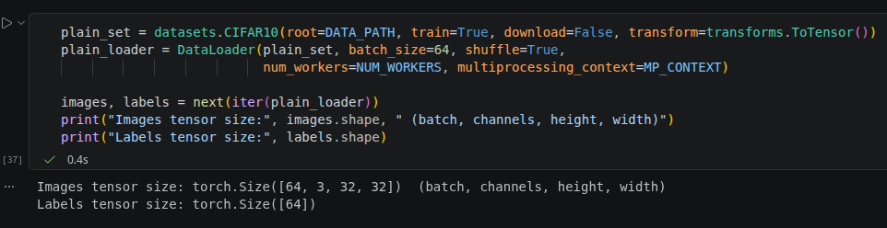
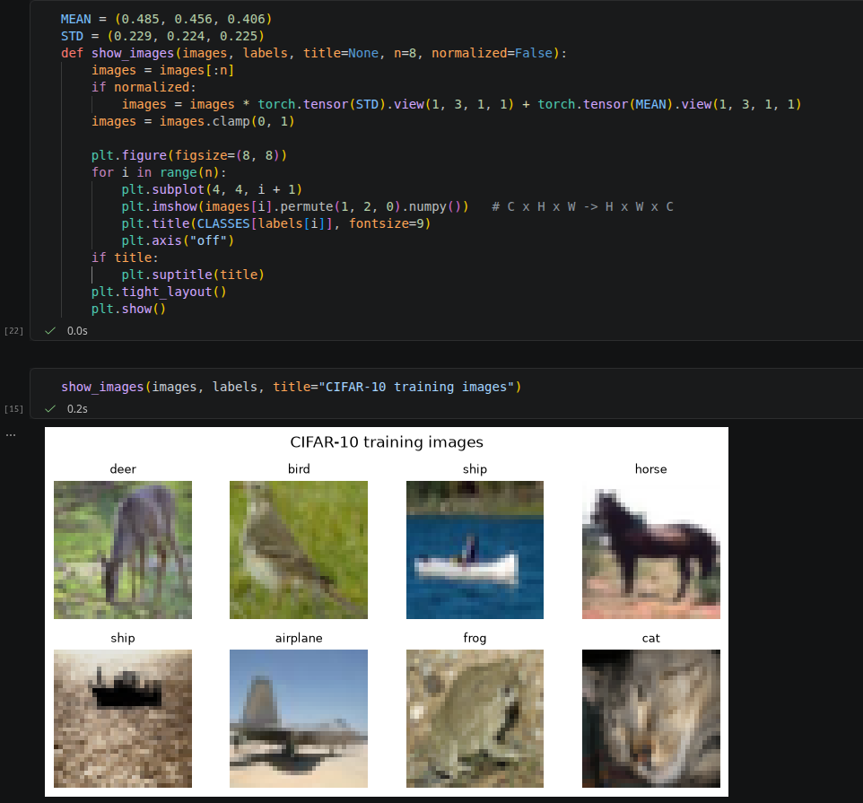

Task 4: Dataset Augmentation

Instructions:
- In this assignment, you may find that data augmentation helps you a lot (or possibly hurts your performance).
- Play around with various data augmentations we will suggest some:
  - ToPILImage - This one is useful for a lot of the built in transforms which expect PIL images.
  - RandomHorizontalFlip
  - RandomResizedCrop
  - ColorJitter
  - RandomRotation
  - Normalize
  - Adding various types of noise
  - ToTensor - PyTorch expects the output from the dataset to be a tensor in CxHxW format.
Note: You should be careful about which of these you apply to the test data. You usually don't want to apply noise to the test data, but you do want to normalize it the same way for example.

Deliverables:
- Apply your code with various Dataset Augmentation as mentioned above.

We have 2 custom augmentations:
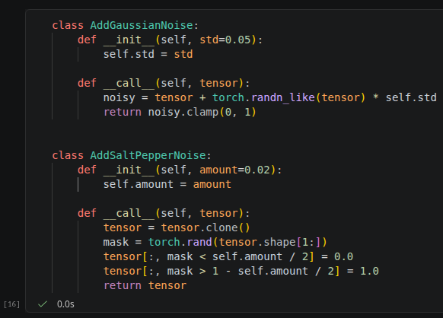
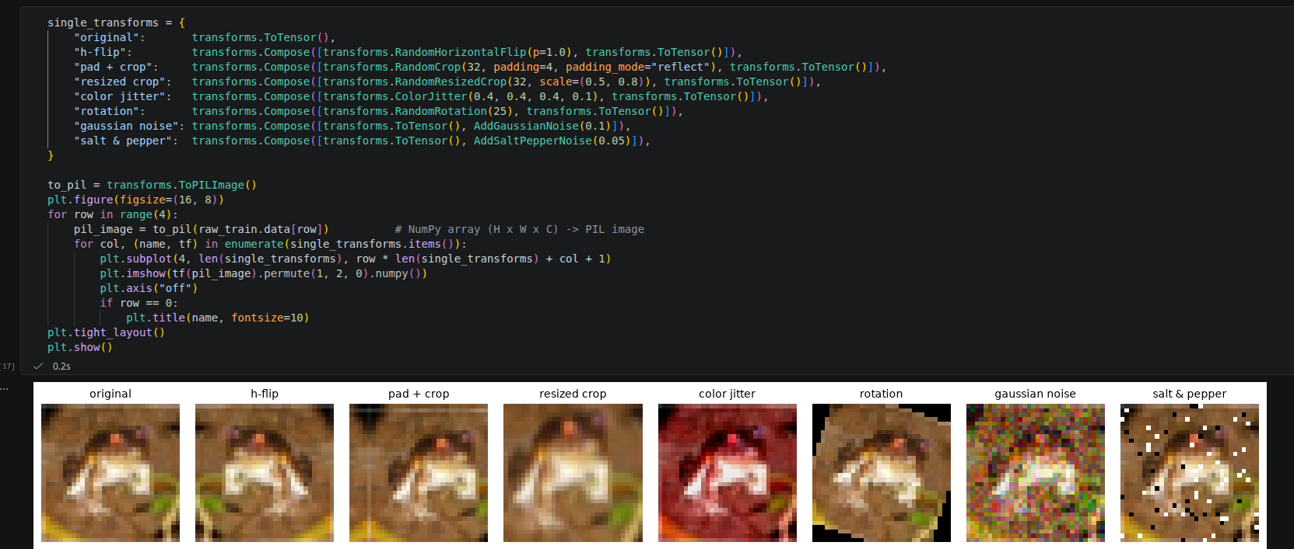

The actual augmentation techniques used for training each model are divided into 3 settings:
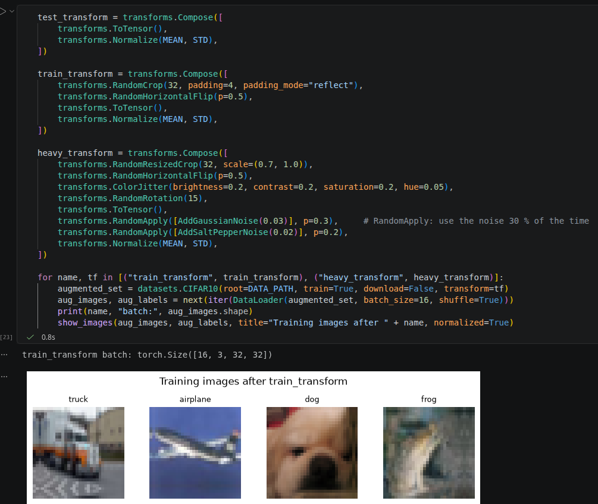
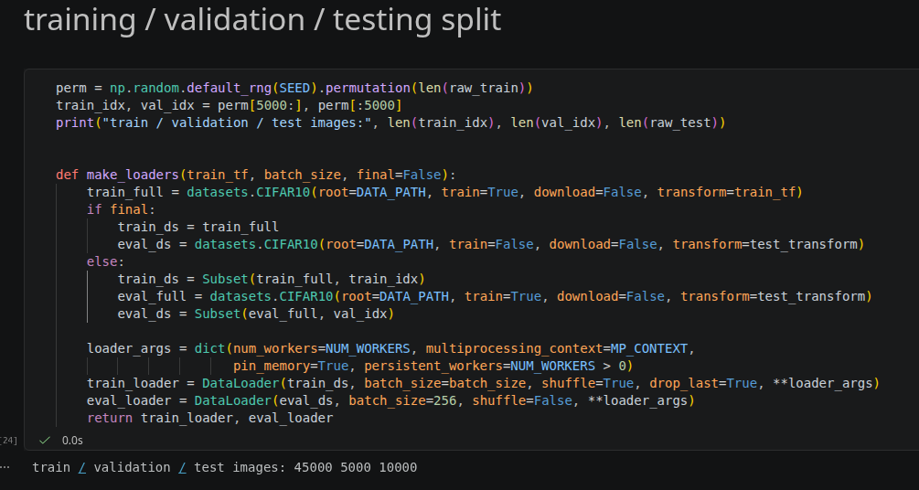

Task 5: Training Function and Tuning hyperparameters

Instructions:
- Generally, it is useful to see how your training is going. Often people print their loss to make sure it goes down and their accuracy to make sure it goes up. But pictures are better than words. So for this part, you should record and plot the training loss, test loss, and test accuracy (and whatever else you want).
- Try different architectures and hyperparameters

Deliverables:
- Screenshot of your python source code that contains your traing function with above requirements
- What design that you tried worked the best? This includes things like network design, learning rate, batch size, number of epochs, and other optimization parameters, data augmentation etc
- What was the final train loss? Test loss? Test Accuracy? Provide the plots for train loss, test loss, and test accuracy.

The training function (that calls train() and test()):
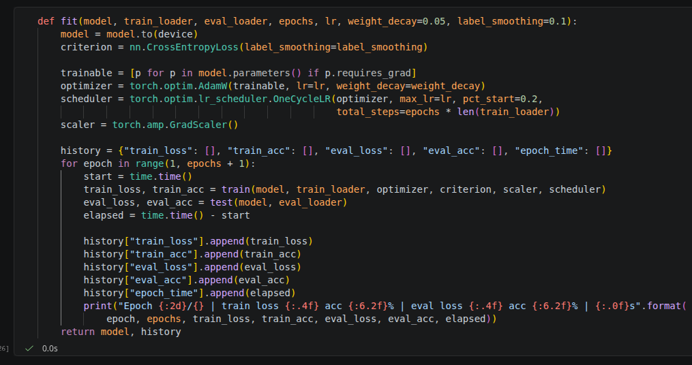

The function used to plot history of training and testing:

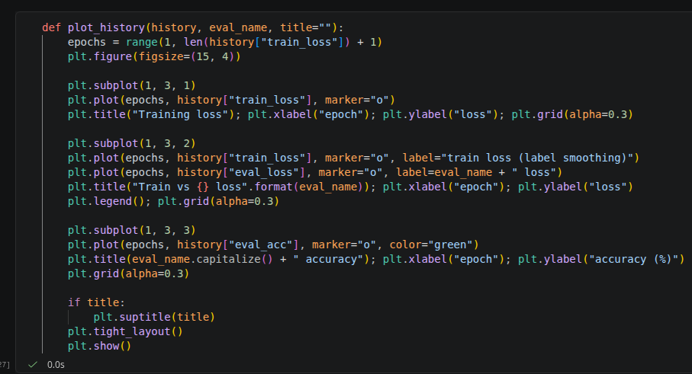

Next would be the actual training section, we set a list of experiments to choose which model performed best and at what settings (lr, augmentation, model):

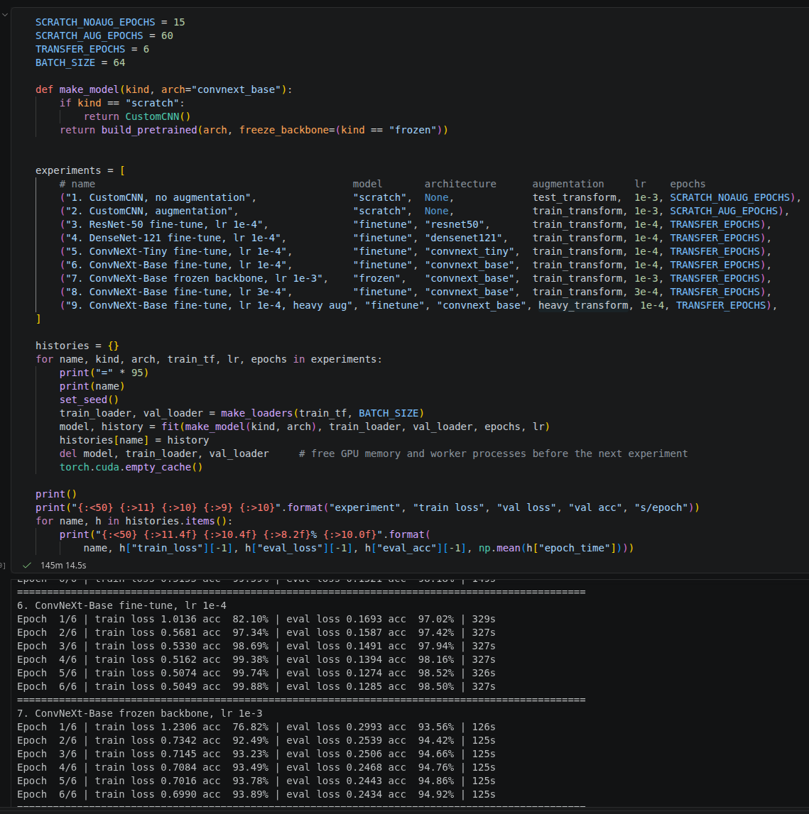
And the summary table:
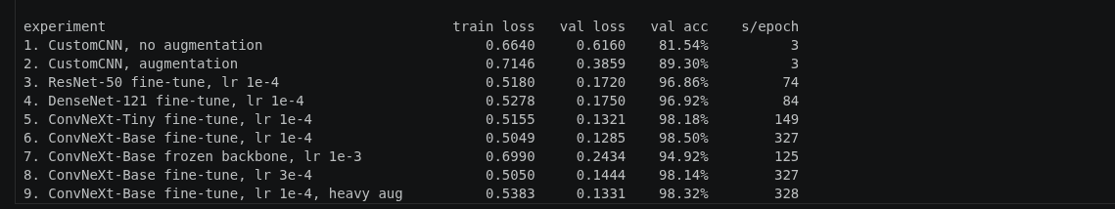

After choosing the best model we further trained it with more epochs:

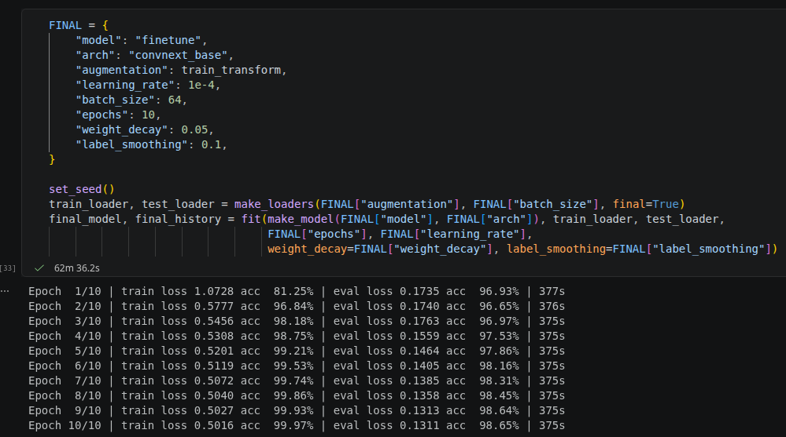
We used a dictionary for the ease of changing the settings, we first had the heavy augmentation but after training we found that this one had the best accuracy.

Next we have the plots:
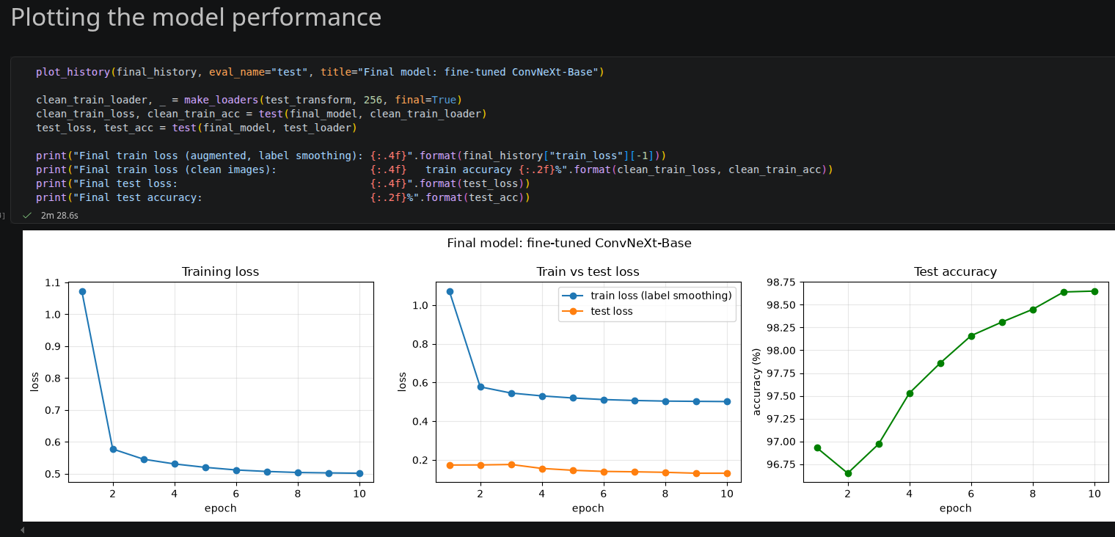

Results summary (what we chose):
Best network design: transfer learning using ConvNeXt-Base which is pretrained on ImageNet. last layer (the fully connected layer) replaced by Linear(1024, 10) (10 classes), all layers fine-tuned (unfrozen). Images upsampled from 32×32 to 224×224 (because of the ImageNet), ImageNet normalisation, optimizer: AdamW (peak lr 0.0001, OneCycle schedule, weight decay 0.05), label smoothing 0.1 for the cross entropy loss, stochastic depth 0.2, batch size 64, mixed precision (used for faster computation) (float16), 10 epochs on all 50,000 training images.

Train loss: 0.5016
Train accuracy: 99.99%
Test loss: 0.1311
Test Accuracy: 98.65%

Augmmentation used in Final model: {
1- Horizontal flips
2- cropping
3- ToTensor
4- Normalization
5- ToPIL
} Which had 98.65% accuracy

But we also tested on more augumentations but had less accuracy: (on the same architecture and transfer learning model):
{
1- Horizontal flips
2- cropping
3- resized cropping
4- color jitter
5- rotation
6- gaussian noise
7- salt and pepper
8- ToPIL
} which reached accuracy of 98.32%

Task 6: Save your source code

Instructions:
- Save your python source code

Deliverable:
- Submit your Github link of your source code along with this document, which includes all screenshots via Blackboard.

GitHub repo (click it)

-
End of Assignment -

Grading Rubric
Criterion | Excellent | Good | Developing | Poor | Marks
Task 1: Getting the CIFAR Dataset | Dataset loaded correctly with clear screenshot showing successful  execution | Loaded correctly but screenshot is unclear | Dataset loaded with issues or incomplete evidence | Not loaded  / missing screenshot | 0.5
Task 2: Defining the Network | All clear screenshots | Minor mistakes or missing small details | Several missing description or unclear screenshots | Not answered / incorrect / missing  evidence | 2
Task 3: Loading Data | All clear screenshots | Minor mistakes or missing small details | Several missing description or unclear screenshots | Not loaded  / missing screenshot | 0.5
Task 4: Dataset Augmentation | All datasets augmentation implemented | Major datasets augmentation implemented | Minor datasets augmentation implemented | Not done | 2

Task 5: Training Function and Tuning parameters | Tuning parameters and model architecture created, screenshot included, and resultlts description explained  accurately | Tuning Parameters and model architecture correct but results description is weak | Tuning Parameters and model architecture corect but incorrect results description | Not done | 2
Task 6: Save your source code | Source code save succefully | Source code save succefully done but minor  missing item | Source code save incomplete or file format  incorrect | Not submitted / missing | 0.5
Total |  |  |  |  | 7.5

